CRITICALITY SAFETY ANALYSES OF THE LATIN AMERICAN CASK FOR TRANSPORTATION AND INTERIM STORAGE OF SPENT FUEL FROM RESEARCH REACTORS

Hugo Moura Dalle

Centro de Desenvolvimento da Tecnologia Nuclear – CDTN/CNEN
Caixa Postal 941 – Cidade Universitária – Pampulha
30123-970 – Belo Horizonte/MG – Brazil

ABSTRACT

This report presents the criticality safety calculations carried out for the Latin American interim storage and transportation cask. Such cask is being designed to spent fuel elements of research reactors in the region. The Monte Carlo transport code MCNP4B was utilized in the analyses.

Key Words: Criticality Safety, MCNP4B, Cask, Spent Fuel, Research Reactors

1. INTRODUCTION

In 2001, the International Atomic Energy Agency – IAEA – started the coordination of the project RLA/4/018. This project, named Management of Spent Fuel from Research Reactors, has supported a joint effort of Latin American research reactors operators in Argentina, Brazil, Chile, Mexico, and Peru to accomplish with the objective on to “define the basic conditions for a regional strategy for managing spent fuel which will provide solutions that are in the economic and technological realities of the countries involved, and in particular, to determine what is needed for the temporary wet and dry storage of spent fuel from the research reactors in the countries of the Latin American region and to establish forms of regional cooperation for storage of the spent fuel or its derivatives”.

Such work get considerable importance since the USA spent fuel take-back program will be a finished option in May, 2006. After that the Latin American research reactors operators will need to identify and assess all possible options which could be implemented to deal with their spent fuel by themselves.

Part of the project consists in to design a cask for interim storage and transportation of the spent fuel produced by these research reactors. In Latin America there are two main types of research reactors under operation: TRIGA and MTR reactors. Such concern is being taken in to account in the cask design that must be suitable for the different fuel elements used in these reactors.

The criticality safety analyses of the cask was carried out utilizing the Monte Carlo transport code MCNP4B [1]. Regarding licensing purposes the KENO module of the SCALE [2] package is also going to be used in such calculations, however, for while just MCNP results are available.

The main concern of the cask criticality safety analyses is to guarantee that the nuclear fuel inside the cask will be maintained safely sub-critical, under both, normal conditions as well as under accident conditions. The cask leak-tight containment shall be able to prevent water penetration in to the cask cavity. This is applicable for normal conditions and also after the cask suffers the type B tests.

2. DESIGN CRITERIA

As recommended by IAEA [3, 4] the calculated neutron multiplication factor, using Monte Carlo transport methods must be, for normal conditions as well as under accident conditions, lower than 0.95. Such condition can be mathematically expressed as,

(keff +2σ) < 0.95.

This condition must be guaranteed under an optimally moderated situation that corresponds to the cask totally water flooded.

3. FUEL ELEMENTS DATA

Several fuel elements types have been used in the Latin American research reactors, however, for while only two types were analyzed. The first one refers to the MTR fuel elements, box type. Actually, these fuel elements are the standard type manufactured by CNEA (Argentinean Atomic Energy Commission) for its RA-3 research reactor [5-7]. The other fuel elements type considered is the TRIGA type, indeed the fuel elements used in the TRIGA IPR-R1 reactor [8, 9]. The main characteristics of these two types of fuel elements are summarized in tables 1 and 2 and in figures 1 and 2. The RA-3 standard fuel elements have 19 fuel plates fueled with U₃O₈-Al in an Aluminum cladding assembled in an Aluminum structure and the IPR-R1 (TRIGA) fuel elements are cylindrical bars fueled with a metallic Uranium and Zirconium-Hydride homogenous alloy also in Aluminum cladding.

Further calculations shall be performed in order to analyze the other specific fuel elements types currently used in the other Latin American research reactors. Concerning this purpose the material and geometry data for these fuel elements need to be supplied by the other research reactors operators involved in the project.

Table 1 – Compositions of the Fuel.

 | MTR Fuel Elements (RA-3) | TRIGA Fuel Elements (IPR-R1)
Mass of U3O8 (g) | 1743.2 | ----
Mass of HZr (g) | ---- | 2250
Mass of H (g) | ---- | 24.5
Mass of Uranium (g) | 1475.7 | 188
Mass of U235 (g) | 290.7 | 37.2
Mass of Aluminum (g) | 626.1 | ----
Enrichment (% mass) | 19.75 | 19.81
Density (g/cm3) | 4.8 | 6,2

Table 2 - Dimensions and Materials Data

Component | Dimension (cm) | Material
MTR Fuel Plates
Active Zone
Thickness | 0.07 | U308-Al (ρ=4.8 g/cm3)
Width | 6.0 | U308-Al
Height | 61.5 | U308-Al
Cladding thickness | 0.04 | Aluminum (ρ=2.7 g/cm3)
Plates Height | 65.5 | Aluminum
Others | as figure 1
TRIGA Fuel Elements
Active Zone
Outer diameter | 3.73
Lenght | 72.24
Fuel diameter | 3.56 | U-ZrH (ρ=6.2 g/cm3)
Cladding thickness | 0.076 | Alumínio (ρ=2.7 g/cm3)
Fuel Height | 35.56
Axial reflectors | 10.16 | Graphite (ρ=1.7 g/cm3)
Others | as figure 2

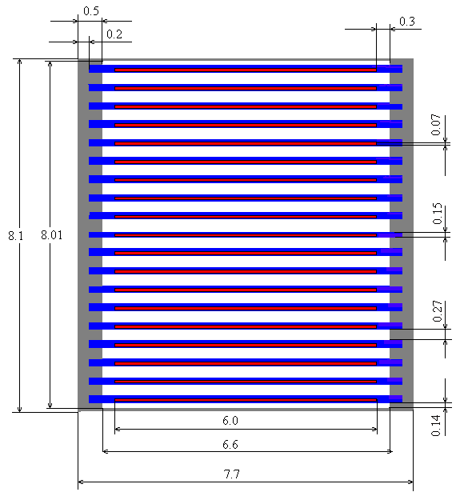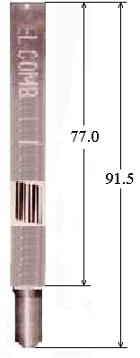

Figure 1 – RA-3 standard fuel element
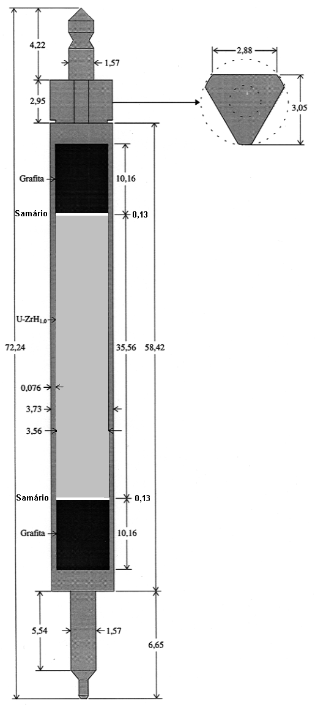

Figure 2 – IPR-R1 Aluminum cladding fuel element

4. CASK GEOMETRY AND MATERIAL MODELING

The geometry and material modeling of the cask follows the characteristics showed in the figure 3. All dimensions in the figure are in millimeters and no component tolerances are taken in to account. It means that these dimensions shall be the minimum accepted for manufacturing process.. The cask has an inner and an outer shell (liner) made with stainless steel ANSI 304. A lead shield in between the shells completes the model.

Due to the different types of fuel elements used in the region many baskets shall be designed. Currently, the calculations were performed considering only two types of basket, both made with SS304. One for MTR elements, which hosts 21 fuel elements and another basket for TRIGA with 78 locations. The geometry data of the TRIGA basket are shown in figure 4.

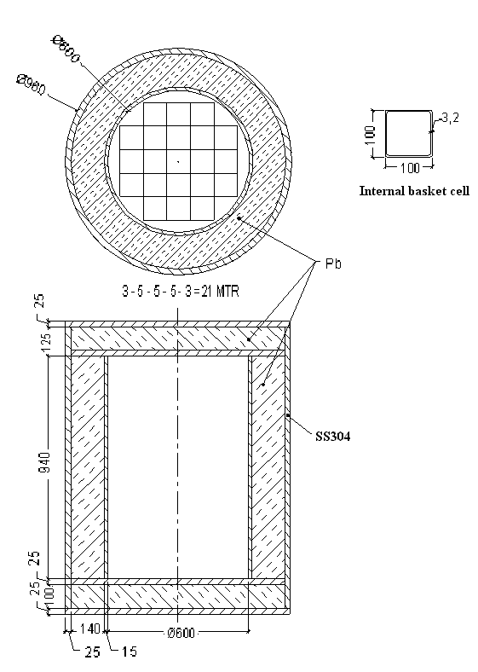

Figure 3 – Schematic drawing of the cask with the 21 MTR basket

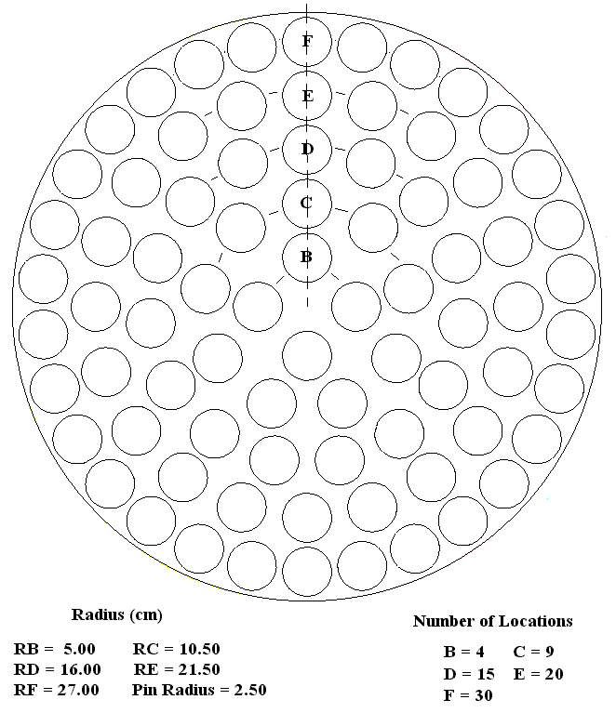

Figure 4 – Schematic drawing of the TRIGA basket

5. CALCULATION METHOD

The criticality safety calculations were performed using the MCNP4B code. It is a multipurpose Monte Carlo program used for stochastic simulation of particles transport (neutrons, photons and electrons). There are available for the code point-wise and multi-group cross sections libraries, including data from ENDF/B-VI, many variance reduction techniques and besides eingenvalue results (keff ) many other results are available through the tallies. MCNP is a 3D code and has graphical resources very useful for modeling visualization. Figure 5 is a picture of the MCNP cask model produced with this visualization tool.

In the adopted model every criticality calculation assumes conservatively that the fuel elements are fresh, it means that no burnup is considered and it is a very conservative hypothesis as such situation definitively is not the standard for a spent fuel elements cask. The masses of fissile material in the fresh fuel elements were informed by the reactors operators. No poisoning effect is considered and in particular, for TRIGA fuel, the Samarium burnable poison discs are not taken in to account.

All calculations were carried out using the point-wise cross-sections library based on ENDF/B-VI data. The calculations were performed considering room temperature, equal to 293 Kelvin. No temperature corrections were applied to the MCNP cross-section data. A very accurate geometrical model for each fuel element of the basket is used. All simulations used 5000 neutron histories and 750 cycles, skipping the 50 first cycles in order to avoid fluctuations coming from statistical uncertainties.

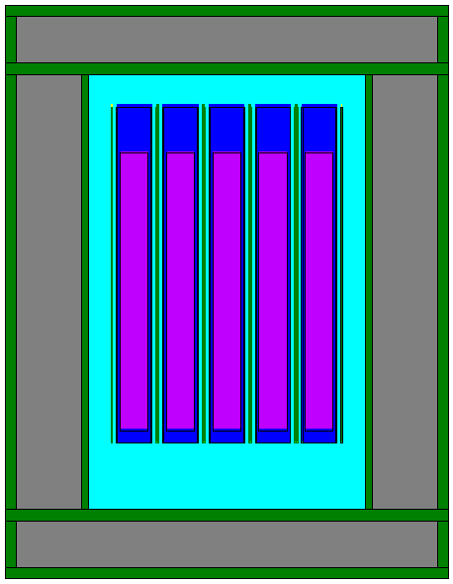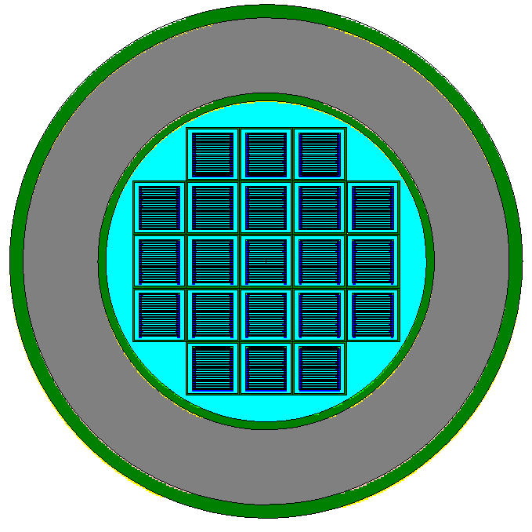

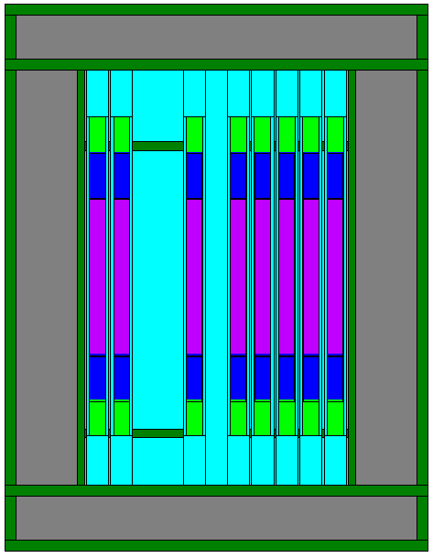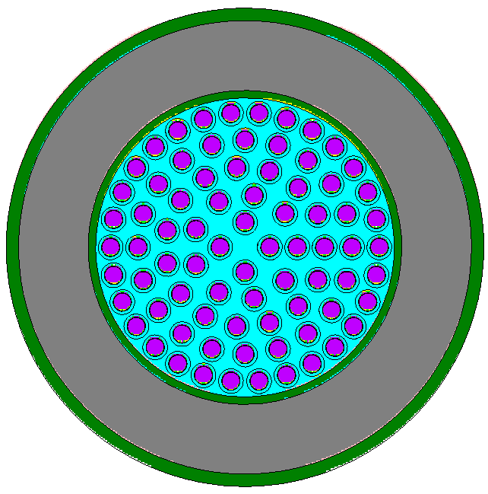

Figure 5 – MCNP cask model view with the baskets for MTR and TRIGA fuel elements

Regarding the neutrons moderation three situations were analyzed. The first is the normal operational condition in which the cask is fully dry and just air surrounds the fuel elements. The two others consist in accident conditions in which the cask is totally water flooded, being one situation corresponding to only the cavity flooded and in the another situation the cavity is flooded and also the whole cask is surrounded by a 30 cm thick layer of water. Furthermore, only to the MTR21 basket, it was simulated a case in which the dimensions of the internal basket cells were reduced from 10.0 cm to 8.74 cm in order to simulate a situation in which the fuel elements are as close to each other as possible.

As a design requirement the cask and baskets shall keep their integrity after the type B tests. Nevertheless, there may be local deformations of the cask inner liner and basket. This situation must be analyzed as well, however, such criticality safety analyses only can be performed after the type B tests results become available.

6. RESULTS

The criticality calculation results are summarized in tables 3 and 4. They present the keff ± 2σ to the cask loaded with the MTR basket or with the TRIGA basket. In both cases the results are available under the aforementioned moderation conditions.

The highest keff is to the cask loaded with MTR21 basket, inside and outside flooded and with reduced dimensions of the internal basket cells. One can note that under normal conditions, in which the cask is dry, the keff of the MTR basket is so small while for TRIGA basket it is almost a half of the value to the cask flooded. Such fact represents well the importance of the Zirconium-hydride alloy as moderator in the TRIGA fuel.

Table 5 – Criticality Results for MTR Fuel (RA-3)

Case | (keff ± 2σ) | Remarks
CA21AR | 0.05073 ± 0.00008 | 21 MTR and Air inside the cask
CA21AG | 0.86348 ± 0.00084 | 21 MTR and water inside the cask
CA21AGF | 0.86412 ± 0.00084 | 21 MTR and water inside and outside the cask
CA21AX | 0.89890 ± 0.00082 | 21 MTR, water inside and outside the cask and 8.74 cm side length of the internal basket cells

Table 6 – Criticality Results for TRIGA Fuel (IPR- R1)

Case | (keff ± 2σ) | Remarks
CA78AR | 0.41213 ± 0.00066 | 78 TRIGA elements and Air inside the cask
CA78AG | 0.87049 ± 0.00072 | 78 TRIGA elements and water inside the cask
CA78AGF | 0.87165 ± 0.00070 | 78 TRIGA elements and water inside and outside the cask

In any case, concerning the criticality safety criteria mentioned in section 2, it is guaranteed that for both baskets the cask can be loaded and unloaded safely. Thus, the fuel elements may also be stored or transported safely sub-critical even in the hypothetical situation of the cask to be water flooded.

7. CONCLUSIONS

The simulations show that concerning the criticality safety criteria mentioned in section 2, the sub-criticality is guaranteed for the cask loaded with both types of baskets here analyzed, the MTR21 and the TRIGA78. Thus, the fuel elements may be stored or transported safely sub-critical even in the hypothetical situation of the cask to be water flooded.

8. REFERENCES

[ 1] Briesmeister J. F., MCNP – A General Monte Carlo N-Particle Transport Code, Version 4B, LA-12625-M, 1997.

[ 2] Oak Ridge National Laboratory. SCALE4.4A Eletronic Manual. ORNL/RSICC, 2000.

[ 3] Safety Series Nº 6. Regulations for the Safe Transport of Radioactive Materials. International Atomic Energy Agency Vienna, 1985.

[ 4] Safety Series Nº 37. Advisory Material for the IAEA Regulations for the Safe Transport of Radioactive Materials. International Atomic Energy Agency Vienna, 1985.

[ 5] Medina E. G., Nassini H. E., Informe de Diseno en Condiciones Normales de Operacion de los Elementos Combustibles de Bajo Enriquecimiento (ECBE) Normal y de Control Destinados al RA-3. CNEA, UPESN, IT-IEC 02/90, Argentina.

[ 6] Perez E. E., Descripción del Prototipo ECBE de 19 Placas Combustibles para Irradiacion en el RA-3. CNEA, Departamento Combustibles Nucleares, Argentina.

[ 7] Personal communication of Mr. Jorge Quintana from Centro Atômico Ezeiza, Argentina, at IPEN/CNEN, May of 2002, São Paulo, Brazil.

[ 8] Dalle H. M., Cálculo Neutrônico do Reator Triga IPR – R1 Utilizando WIMSD4 e Citation. Dissertação de Mestrado, UFMG, 1999, Belo Horizonte, Brazil.

[ 9] Dalle, H. M., Pereira, C., Souza, R. G. P. Neutronic calculation to the TRIGA IPR-R1 Reactor using the WIMSD4 and CITATION codes. Annals of Nuclear Energy, Vol 29, Aug 2002 pp. 901-912.

